Blair Mueller

DIG540

Database Schema

Ancient Language Database

My database will feature vocalizations of ancient languages. I have been writing a manuscript on Ancient Egypt for nearly a year, and as I researched the international relations of the 18th dynasty, I realized how many languages were present at the time and how they are still being studied and spoken today. Learning ancient languages is a requirement for many degrees and certifications in Near Eastern Studies, European Studies, and Latin America along with more specialized programs such as Egyptology, Hittiteology studies, and Maya studies.

This site will be network-based, so the collection can be added to and commented on by the public. This will show not only how many ancient languages and dialects there are but also emphasize the efforts being made to study, speak, and comprehend them through linguistic and cultural means. I will also feature cultural descriptions on this site. In order to learn a language, it is best to understand the culture from which it was born.

I intend to highlight the linguistic interpretations of these languages and promote discussions concerning their accurate pronunciation and portrayal along with providing students and scholars the opportunity to speak the language themselves and upload it to the site as an example of their work. For this, the submissions will be divided into levels of Novice, Intermediate, Advanced, and Superior. Given the debate around the proper pronunciation, annunciation, and tone of these languages, these levels are self-diagnosed by the person(s) who submit to the database. However, the higher the level of the submitter, the more likely they have the generally accepted proper pronunciation, thus they can serve as examples to the lower leveled speakers.

Submissions can be of a variety of different topics. For example, individual symbols, letters, alphabet, conversation, phonetics, grammar, phrases, translations, literature, music lyrics, or movie quotes are only a few of the potential topics that can be addressed in this database.

This site will be useful for the study of ancient languages and culture while promoting further discussion and debate. It will also offer people the opportunity to use their own voice and practice their studies while actively contributing to the efforts to preserve these ancient languages for the future.

Fields Descriptions:

**audio**: An example of the spoken language and dialect from either a specialist such as a professor, instructor, native speaker, or a student from any language level. These audio files can serve as examples and will be organized in terms of their complexity and the language level of the submitter. Given that pronunciation, annunciation, emphasis and tone is uncertain in these ancient languages, they serve as examples, samples, and attempts. There may be more than one of these with each language and/or dialect.

audio_file: The name of the audio file that was uploaded to the site.

audio_id: The identification number of the audio file.

background: The description of the “submitter” who is recognized as the people/person who provided the sample. This could be the extended version of the “background” used for the “sample.” This can include both academic and personal details about the submitter.

background: The brief academic background of the individual or people who submitted the audio file. This would concern their level in the language, level of academia, what interested them in the language, and why they are submitting this individual file.

**culture**: The social group from which the language originated and/or influenced.

culture_id: The identification number of the culture.

date_recorded: The date when the submitter recorded the sample. Given that each user can submit more than one sample, this field can be used to show the submitter’s development within one or more dialects or languages over a period of time.

description: Extra details of the identified culture on such matters that have not been referenced to in the fields of name, location, time_period, and history. For example, this description section could include matters concerning: cities, population, deities, social customs, food, trade, warfare, etc.

description: The description of the sample audio file concerning the language, dialect, type, and title.

**dialect**: The dialect of the language. A specific form of a language usually found in a certain region, culture, or group of people.

dialect_id: The identification number of the dialect.

history: This section fills in the details other than the dates of the culture’s existence. This section incorporates the culture’s chronology of important events, king lists, list of other important people such as royal family members, court officials, individuals who made contributions through literature, architecture, healing, science, etc. This section is meant to clarify the culture’s historical background for the language learner because, in order to understand the language, one must comprehend the culture.

**language**: The name of the language that is being described, studied, and/or spoken.

**language_culture**: The connection between culture and language that must be identified.

language_id: The identification number of the language that is being described, studied, and/or

spoken.

language_level: This will be based on this chart. The levels will be Novice, Intermediate, Advanced, or Superior. These are usually used for modern languages, and given the different levels of knowledge available for these ancient languages, along with debates concerning proper pronunciation, tone, emphasis, and annunciation, these levels will be self-described by the “submitter.”

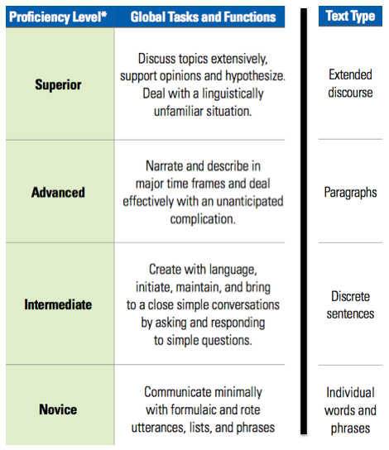

location: The place and/or region where the culture is known to have existed.

name: The name of the language that is being described, studied, and/or spoken.

name: The name of the culture that is connected to the language.

name: The name of the dialect.

name: The name of the submitter(s) of the audio file.

region: The region where the language began in ancient times.

submission_type: This section will specify and help categorize the type of submission. It can either be an: alphabet, conversation, example, grammar, literature, movie_quote, music_lyrics, phonetics, phrase, translation, etc.

**submitter**: The information pertaining to the person who uploaded an audio file onto the site.

submitter_id: The identification number of the submitter.

time_duration: The length of time of the spoken sample.

time_period: This is a description of the period of time in which a culture existed. If the information is available, this is also the section where the time period of each dialect used within the culture will be shown.

translation: This section is where the submitter will offer a translation of their work in a modern language. This site will be available all over the world, so a translation should also be available in the submitter’s language of choice, be it English, French, German, Chinese, Japanese, Korean, Arabic, etc. Google Translate or another translation service can then be used by the user to read the translation in their own language.